**The Evolving Landscape: A Look at the US Banking System Through Time.**

**(Presented By Alan Stuart K)**

**Introduction:**

The banking system serves as the lifeblood of any nation's economy. It facilitates the flow of money, provides access to credit, and fosters financial stability. The US banking system has undergone a remarkable transformation throughout history, adapting to the nation's needs and responding to economic challenges. This paper explores this evolution, examining key eras and aspects that shaped the present-day system.

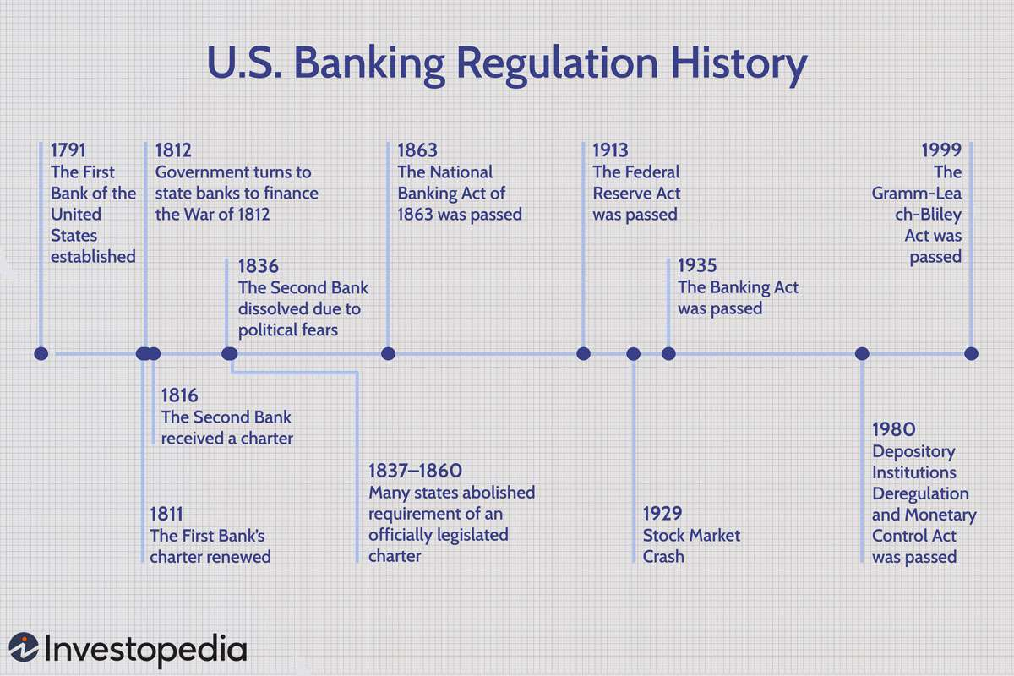

**Part 1: Colonial Era and Early Republic (1780s-1830s):**

**Timeline:**

* 1781: Bank of North America established
* 1791: First Bank of the United States chartered

**Founding Principles:**

The birth of the US banking system was marked by debate. Alexander Hamilton, the first Secretary of the Treasury, envisioned a central bank modelled after the Bank of England. This institution would manage the national debt, issue currency, and promote economic growth. However, Thomas Jefferson and other Democratic-Republicans opposed a powerful central bank, fearing it would concentrate economic control and favour wealthy elites. They advocated for a decentralized system of state-chartered banks.

**State-based Banking System:**

Following Jefferson's philosophy, a decentralized system of state-chartered banks emerged. Each state established its own regulations and oversight, leading to a patchwork of banking practices and currencies. While this system offered flexibility, it also presented challenges. State banks varied widely in stability, and the lack of uniformity in currency created confusion and inefficiency.

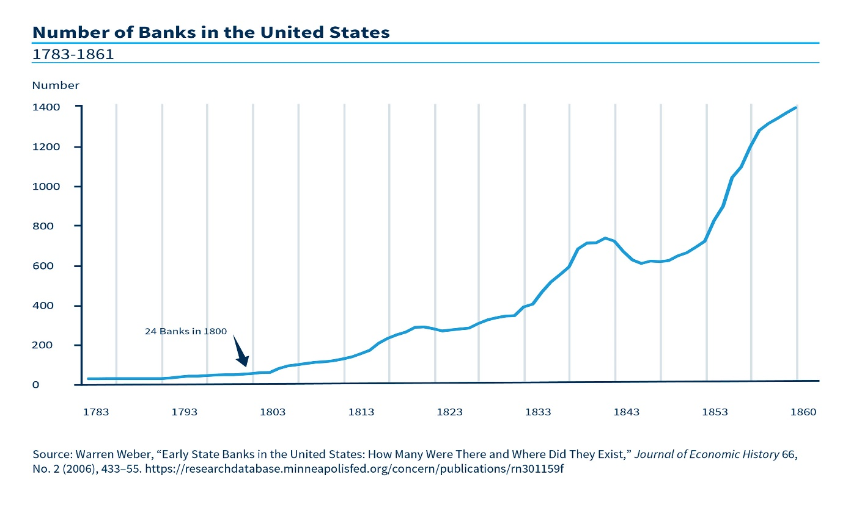

**Part 2: The National Banking System and Civil War (1860s):**

**The National Banking Act (1863):**

The outbreak of the Civil War highlighted the need for a more unified banking system. The National Banking Act of 1863 established a national banking system. This act:

* Created a framework for federally chartered banks.
* Standardized national bank notes backed by US government bonds.
* Established the Office of the Comptroller of the Currency (OCC) to regulate national banks.

**The Second Bank of the United States (1816-1836):**

It's important to briefly acknowledge the Second Bank of the United States, established in 1816. This central bank aimed to stabilize the financial system after the War of 1812. However, political opposition and concerns about its power led to its expiration in 1836.

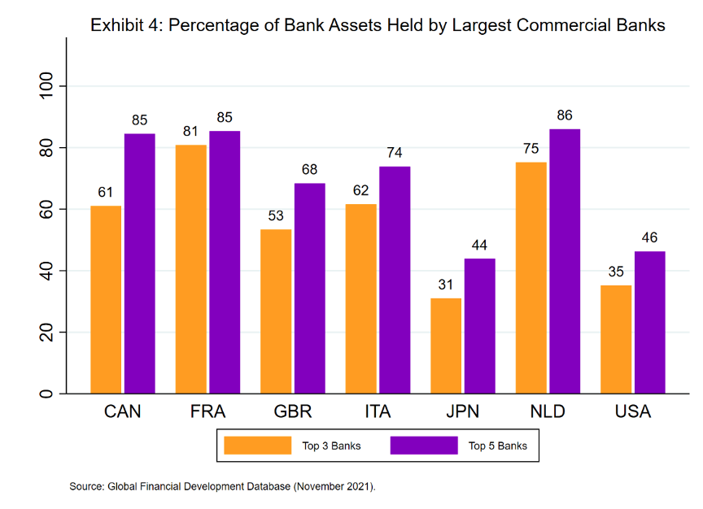

**Part 3: The Gilded Age and Progressive Era (1870s-1910s):**

**Banking Panics:**

The late 19th and early 20th centuries witnessed several financial panics, periods of intense fear and loss of confidence in the banking system. Bank runs, where depositors rushed to withdraw their money simultaneously, could cripple banks and trigger economic downturns. The Panic of 1873 and the Panic of 1907 highlighted the vulnerability of the banking system to economic shocks.

**Rise of Trust Companies:**

Alongside traditional banks, trust companies emerged during this period. These institutions offered new financial services, including wealth management, investment banking, and acting as trustees for estates. While they filled a gap, trust companies also operated outside the regulations governing traditional banks.

**Calls for Reform:**

The lack of central control, limited regulation, and recurring financial panics fuelled calls for reform. Progressive reformers advocated for a central bank to provide greater stability and regulate the financial system.

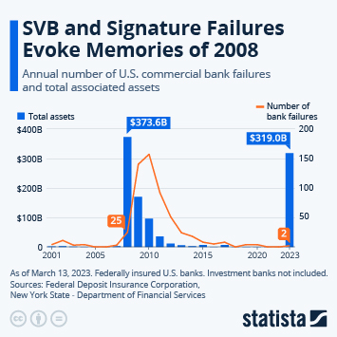

**Part 4: The Federal Reserve System and The Great Depression (1913-1930s):**

**The Federal Reserve Act (1913):**

In response to growing concerns, the Federal Reserve Act of 1913 established the Federal Reserve System, the central bank of the United States. The Fed's primary functions include:

* Conducting monetary policy by influencing interest rates and the money supply.
* Supervising and regulating banks.
* Providing financial services to the US government.

**The Great Depression (1929):**

The Great Depression exposed weaknesses in the banking system. Thousands of banks failed due to a combination of factors, including risky lending practices and a lack of deposit insurance. The Federal Reserve, though still young, attempted to intervene by lowering interest rates and increasing the money supply. However, its effectiveness was limited during this unprecedented economic crisis.

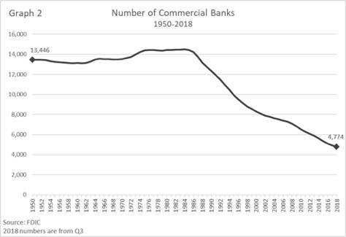

**Part 5: The Post-War Era and Modernization (1940s-2000s):**

**The Bretton Woods System (1944):**

Following World War II, the Bretton Woods Agreement established a new international monetary system. Major currencies were pegged to the US dollar, which in turn, was backed by gold. This system fostered global economic stability and trade for several decades.

**Regulation and Deregulation:**

The post-war era also saw significant changes in banking regulations. The Glass-Steagall Act of 1933 aimed to prevent risky practices by separating commercial banking (taking deposits and issuing loans) from investment banking (raising capital for businesses). However, deregulation efforts in the 1980s and 1990s gradually eroded these barriers, culminating in the repeal of Glass-Steagall in 1999.

**Technological Advancements:**

The latter half of the 20th century witnessed a technological revolution in banking. The introduction of Automated Teller Machines (ATMs) in the 1960s, followed by online banking in the 1990s, transformed how individuals access and manage their finances. These advancements increased convenience and efficiency but also raised new cybersecurity concerns.

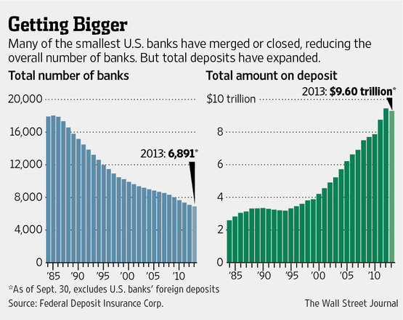

**Part 6: The Great Recession and Beyond (2008-Present):**

**The Great Recession (2008):**

The financial crisis of 2008, sparked by the collapse of the housing market and subprime lending practices, severely impacted the banking system. Several major banks faced insolvency and required government bailouts. This crisis exposed weaknesses in risk management and regulatory oversight.

**Dodd-Frank Wall Street Reform and Consumer Protection Act (2010):**

In response to the crisis, the Dodd-Frank Wall Street Reform and Consumer Protection Act of 2010 aimed to strengthen regulations and prevent future meltdowns. Key provisions included increased capital requirements for banks, creation of the Consumer Financial Protection Bureau (CFPB), and stricter oversight of derivatives trading.

**The Future of Banking:**

The US banking system continues to evolve in the 21st century. New technologies like blockchain and artificial intelligence are reshaping the industry. Fintech startups are disrupting traditional banking models by offering innovative financial services. Cybersecurity threats remain a significant concern, requiring constant vigilance and adaptation.

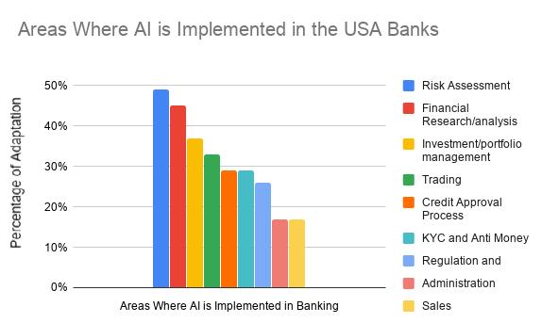

**Conclusion:**

The US banking system has undergone a remarkable journey, shaped by historical debates, economic challenges, and technological advancements. From the early debates between Hamilton and Jefferson to the creation of the Federal Reserve and the rise of online banking, the system has continuously adapted to meet the nation's needs. As we move forward, ensuring a stable, secure, and inclusive banking system is crucial for a healthy and thriving US economy.

